Planet Elt the Cartoon

Exciting, Amusing, and Educational

This cartoon has it all. Planet Elt has adventure, role models, villains, heroes, comedy, battles, imagination, trouble, and so much more. Young children will enjoy this cartoon so much that they won't even realize they are learning the chemistry elements and their reactions with other elements. Go visit About Planet Elt to see why this is not only a fantastic cartoon, but it is very educational as well.

Planet Elt Characters

Come in and meet the Hydras, Oxys, and the Ferons. You will totally love and admire HEATHER. You might even feel a little sorry for the two villains, FRANK and FERD, that are always trying to capture her. HANS, HI and HEY will have you laughing for it is amazing how they always find trouble. And if you admired Bugs Bunny you are going to love OR. If you like the super villain type, the FUROR will certainly be your man. Then there is HERMAN, whose inventions sometimes save the day. Go visit The Characters page to be introduced to these main characters.

The Characters

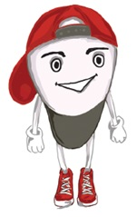 OR 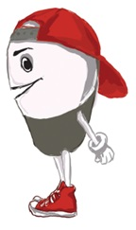

Or is an Oxy. OR defies physics, OR defies logic, OR makes his own rules. He is intelligent, tricky, conniving, manipulating, and deceitful but all in a good way. You do not want to be an enemy of OR. OR is always smiling. If you make him mad or cross him you will get that smile that tells you things are not going to go well for you. Most of the time you don’t even know OR just gave you the short end of the stick until it’s too late. OR also just happens to be the son of QUEEN ORIANA. HERMAN is OR’s best friend.

To get an idea of how OR works here is scene 28 when OR helps HANS, HI, and HEY get out of the Ferons jail while convincing the Feron Soldiers to get in the jail.

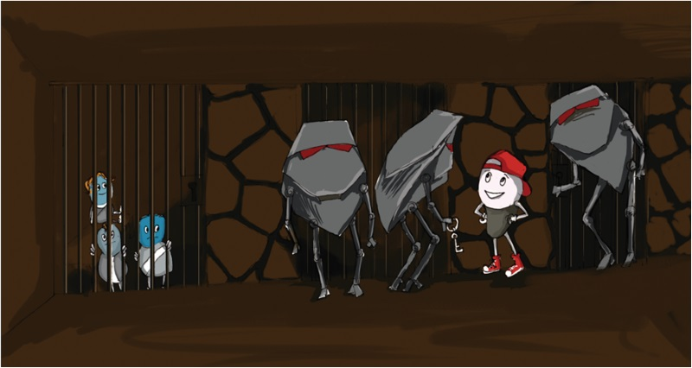

28, EXT. – AT THE FERONS BASE BY TWO ADJOINING CAGES/JAIL CELLS– DAY

The three FERON SOLDIERS are standing guard with HANS, HI, and HEY locked in a jail, just then OR shows up.

OR

At ease soldiers, your boss sent me here to make sure these locks are not defective.

FERON SOLDIER 3

Hold it right there.

OR

Obviously, I’m not one of the little blue creatures, am I?

FERON SOLDIER 4

Well, he isn’t blue, but he sure is little.

OR

Your leader sent me to check the locks that I sold him because I believe one of those locks are defective.

FERON SOLDIER 3

The FUROR sent you?

OR

Yes, the FUROR sent me. If one of those locks are defective and those little blue creatures get away you guys are in big trouble. I know he would be very upset if I went back to him and told him that you did not allow me to check for the defective lock. But if that’s what you want me to do, okay. I will go let him know now. (OR starts to walk back)

FERON SOLDIER 3

NO, no, that’s okay. You can check the locks.

OR

Well, I can’t check the lock that has your prisoners are locked up in so let’s check the lock on the other cage first. I need you three to get inside and push on the lock to see if it breaks.

FERON SOLDIER 3

You want us to go in the cage?

OR

Well, you are far bigger and stronger than the three little blue creatures in the other cage, so if you can’t break it, they can’t break it. Don’t worry, you have a key to get out right?

FERON SOLDIER 3

Oh, that’s right. Okay, will get in and push on the lock.

The three FERON SOLDIERS go in the cage. OR shuts the door and locks it behind them.

OR

Okay, all three of you push and see if you can get out.

The three FERON SOLDIERS push hard and the door remains locked.

OR

Well, that’s good, that one worked. (The three FERON SOLDIERS smile) Hand me the key so I can unlock it and let you guys out.

FERON SOLDIER 3 hands OR the keys. OR walks over to the other cage and unlocks the door holding HANS, HI, and HEY.

FERON SOLDIER 3

Hey, what are you doing?

HEY

I think I am leaving.

HI

You don’t think

HANS

HI, not now.

OR

Shhh (to the soldiers), you should be quiet or someone will come and see you guys locked up in the cage and these three little blue creatures gone. Shhh.

The three FERON SOLDIERS just look at each other as OR, HANS, HI, and HEY walk off.

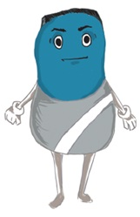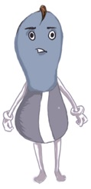HANS, HI, and HEY 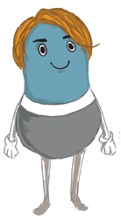

HANS, HI, and HEY are hydras. HANS, HI, and HEY are three amigos, friends, a team. You probably will never see them apart. HANS is the obvious leader due to the fact he is the smartest one, yet certainly not smart. The three combined might make one average intelligent Hydra. Maybe that is why they stay together as a team. HI knows his place behind HANS yet obviously believes himself to be smarter than his buddy HEY and he lets HEY know this often.

Here is an example of the dynamics of HANS, Hi and HEY's relationship. In scene 10 HANS has decided to go where the Hydras were told not to go. Of course it doesn't go well, but you will have to read the script to see what happens.

**10,** EXT. –A PATH UP A MOUNTAIN – DAY

HANS, HI, and HEY are walking along a path up a mountain.

HI

Hey HANS.

HEY

What?

Hi

No not you, HANS

HANS

What?

HI

Weren’t we told never to go over that mountain back there?

HANS

Yea but why? No one said why?

HI

I thought we were told it’s not our territory.

HANS

Then whose is it?

HEY

I don’t know?

HI

(to HEY) You say that a lot don't you? (smiling)

HANS

The Oxys territory is to the north of our territory and there is nobody else. Are we in the Oxys territory?

HEY

No.

HI

No.

HANS

Exactly! Then we are in nobody’s territory. So what could possibly go wrong in going there?

HEY

Gee HANS I never thought if it like that.

HI

That is because you never think.

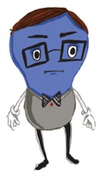 HERMAN 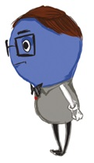

HERMAN is a Hydra. You might say he is the most scientific, and intelligent creature on the planet. HERMAN loves math and science. Even though he seems very intelligent, he is so intense and focused that sometimes he misses some of the simple things as you will see.

Here is scene 31 with HERMAN and KING HONOR. HERMAN has invented a way to send KING HONOR'S son to an island that no one has ever been on before. Unfortunately after all the intense calculating, HERMAN overlooked just one minor detail, getting KING HONOR'S son back from the island. OR saves the day, but you will need to read the script to see how.

31, EXT. – LUSH TROPICAL BEACH NEXT TO A BENT OVER PALM TREE – DAY

KING HONOR and HERMAN are standing next to the tied down, bent over, palm tree. HARM is inside a hollowed-out rock at the tip of the palm tree which is resting on the sand. Lots of other Hydras are all around ready to watch the launch. The Council members are by the KING and HERMAN.

KING HONOR

I am so excited HERMAN. Are you sure your calculations are correct?

HERMAN

Yes KING HONOR, HARM is going to be the first one on No One's Island.

HARM

I am ready to do this.

HERMAN

KING HONOR would you like to be the one to launch him?

KING HONOR

Yes, it would be my pleasure.

HERMAN

Just pull on this rope when I say.

KING HONOR

Ok.

HERMAN

HARM are you ready to be launched.

HARM

Yes!

HERMAN

Ok HARM, hold on. KING HONOR pull the rope.

Just then KING HONOR pulls the rope and the tree launches HARM over the ocean. All the Hydras watch in excitement. Just as HERMAN calculated, HARM lands right on the island and the crowd cheers.

KING HONOR

What a glorious day. Thank you, HERMAN (as he shakes his hand)

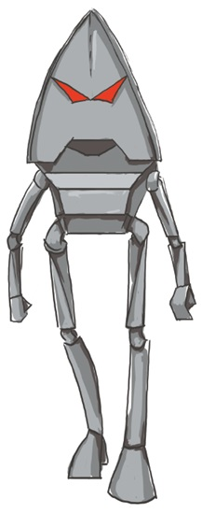 FUROR 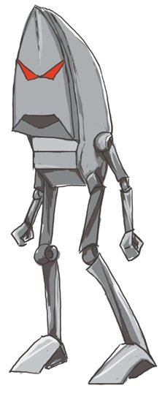

FUROR is a Feron and is as evil as they come. He is the bad guy of all bad guys. He has no heart, no compassion, and no guilt. He has one serious goal and that is to conquer all the territory on Planet Elt.

Here are scenes 12 and 13, which demonstrate how the FUROR gained his power.

12, EXT. – NEXT TO A CAVE IN THE MOUNTAIN – DAY

The FUROR is speaking with one of the COUNCIL MEMBERS. The Ferons flag is flapping in the wind above them.

FUROR

Sir, are you going to discuss and support the invasion?

COUNCIL MEMBER

Yes, we are going to discuss it. But I must inform you I am not voting for it and I have spoken with the others and the majority of us do not support your invasion plans. There will be no invasion.

The council member walks into a highly decorated cave with pillars and markings on the archway stones.

FUROR

The FUROR is furious. He notices there are pillars on each side of the cave holding up the vast decorative arch. He looks around, and there are no witnesses. He uses his extreme strength and punches one of the pillars. It cracks from top to bottom. He walks over to the other pillar. He looks around to verify no one is watching, He again uses his power and strikes the other pillar. The entire cave collapses.

13, .EXT. – A LEDGE A SHORT DISTANCE AWAY FROM THE COLLAPSED CAVE – DAY

The FUROR walks over to the ledge and is now looking down at the army of Ferons.

FUROR

Ferons, I have very important news. There has been a terrible accident. The council cave has collapsed killing all council members. I am now in command of all Ferons.

All the Ferons stands at attention some in fear and some in loyalty to the FUROR.

The FUROR walks down from the ledge to the army below. He is greeted by three of his Lieutenants. He looks directly at one of them.

FUROR

Being that I am now the Supreme Commander, FRAS, I am promoting you to be my General.

GENERAL FRAS

Thank you, Sir!

FUROR

So now GENERAL FRAS, Where are FRANK and FERD with my little blue creature, my prisoner?

GENERAL FRAS

Sir, FRANK and FERD have never returned from their mission, Sir. We have no prisoner.

FUROR

I am getting tired of waiting. I am ready to attack those little blue creatures and take all that territory along the coast. Those little blue creatures are no match for us. We are strong, we are big, we are superior, and the land is just waiting for us to conquer it.

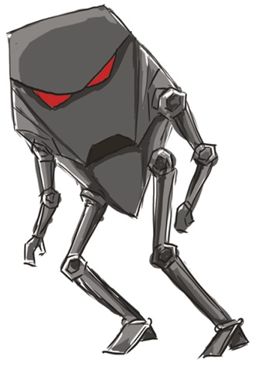FRANK and FERD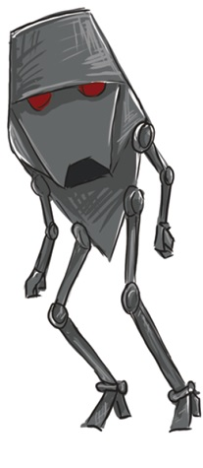

FRANK and FERD are Ferons. FRANK is the boss and FERD is the "whatever you say boss" sidekick. FERD would have no clue what to do if FRANK was not directing him. FRANK'S only goal is to catch that super fast little blue creature we know as HEATHER.

Here are scenes 5 through 9 showing how wrong things can go when FRANK and FERD attempt to catch HEATHER.

5, EXT. – HIGH CLIFF OVERLOOKING THE SANDY BEACH – DAY

FRANK and FERD are Ferons. FRANK is the intense, impatient leader and FERD is his loyal whatever you say I do sidekick. FRANK’s goal is to catch the fast little blue creature that seems to flash by, which just happens to be HEATHER. FRANK sees a roster tail flying in the air and knows that must be that fast creature coming his way any time now. FRANK and FERD are on a high cliff overlooking the beach. Just below them is a narrow section of beach where HEATHER will be speeding right past them. There is a large boulder right on the edge of the cliff and FERD is ready to push it off the cliff to land on the fast little blue creature. FRANK is peaking over the edge of the cliff and sees a rooster tail flying in the air. FRANK knows that it must be that fast creature coming his way now.

FRANK

I see it. Are you ready?

FERD

Yes, yes, just give me the word and this rock is gone.

FRANK

He says with total excitement, “Get ready, get ready, Now!”

FERD

Is “Now” the word Frank?

FRANK

Yes, Yes, push the rock now!

FERD

It's gone Frank I did it I did it!

6, EXT. – SIDE OF THE CLIFF NEXT TO A SANDY BEACH – DAY

The rock falls off the cliff and HEATHER is quickly approaching. It looks to be timed perfectly. But the rock hits a twig that is sticking out of the cliff and gets stuck and stops right there.

7, EXT. – SANDY BEACH NEXT TO THE CLIFF – DAY

HEATHER flashes right by the spot where the rock was supposed to land and is long gone leaving the rooster tail of sand and water settle to the ground.

8, EXT. – HIGH CLIFF OVERLOOKING THE SANDY BEACH – DAY

FRANK

What? What happened?

FERD

Nothing happened FRANK. Nothing at all. The little blue creature got away again.

FRANK

I can see that FERD. Come with me, we are going to see what went wrong.

FERD

Ok FRANK, I’m coming. But it didn't hit the creature, that's what went wrong.

FRANK

I know that! but why? We are going to find out why?

9, EXT. – SANDY BEACH NEXT TO THE CLIFF – DAY

FRANK and FERD make it down from the cliff to the beach. They are under the rock and looking right up at the rock. FRANK sees a little twig sticking out of the cliff holding the rock.

FRANK

There is no way, "NO WAY"! that little twig can hold that rock!

Just then "SNAP", the twig breaks and the rock comes flying down.

FERD

Gee your right again FRANK.

Smash, the rock lands on both FRANK and FERD.

 HEATHER 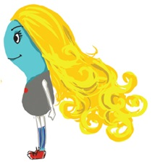

HEATHER is a Hydra. HEATHER is like a goddess to all the Hydras. She is the fastest creature on the planet. In fact, she’s the fastest anything on the planet. She is the kindest, caring, and most polite creature on the planet. HEATHER is absolutely the most perfect role model.

Here in scenes 26 through 28, HEATHER is trying to buy some time for OR to launch his plan. HEATHER had used her speed to tie a long rope around lots of large rocks on the cliffs above the Feron army. Her plan was to use her speed to pull them own, however that did not work as planned. But good ole FRANK came to the rescue so to speak.

26/63, EXT. – ON THE BEACH – DAY

FRANK and FERD are finally getting up after the rocks that were launched at the Feron army had hit them. They dust themselves off.

FRANK

I hate rocks.

Just then Heather comes flying in with the rope in her hand. She tries, by using her speed, to pull the rocks off the cliff with the rope but they are just too heavy for her. She comes to a halt, falls and lands on her back in front of FRANK and FERD.

FRANK

Well, look what we have here. It’s my lucky day.

Heather looks up from the ground and sees FRANK and FERD. Heather then looks up at the rocks on the cliffs tied with the ropes, and then she looks back at FRANK and FERD. She quickly puts the rope around her wrist and hands it to FRANK.

HEATHER

You better pull this rope as fast and as hard as you can or I will be gone.

FRANK immediately yanks the rope quickly but is too late HEATHER leaves a fish tail of sand and is gone.

FRANK

No way. How did she get away?

27/64, EXT. – CLIFFS OVERLOOKING THE BEACH – DAY

Large rocks are falling off the cliffs one after another because FRANK pulled hard enough on the ropes.

28/65, EXT. – ON THE BEACH – DAY

FERD is looking up towards the cliffs.

FERD

Hey FRANK

FRANK

I can’t believe that little blue creature got away again.

FERD

Hey FRANK

FRANK

What?

FERD

Rocks.

FRANK

No, no more rocks.

FERD

Too late FRANK.

Just then the rocks from the cliffs come crashing on FRANK and FERD and the army of Ferons, rolling through them like bowling balls hitting bowling pins.

© 2017 Steve Banevedes